A* (A-Star) Algorithm
Aim
To implement the A* (A-Star) algorithm to find the shortest path between a start node and a goal node using heuristic values.

Objectives
- To understand informed search algorithms.
- To find the shortest path using heuristic information.
- To minimize the total path cost.
- To implement the A* algorithm using Python.

Algorithm
- Start.
- Initialize the graph and heuristic values.
- Insert the start node into the open list.
- Select the node with the lowest f(n) = g(n) + h(n).
- If the selected node is the goal node, display the path.
- Otherwise, expand its neighboring nodes.
- Update the cost of each neighbor.
- Repeat Steps 4–7 until the goal is reached.
- Stop.
\

FLOWCHART

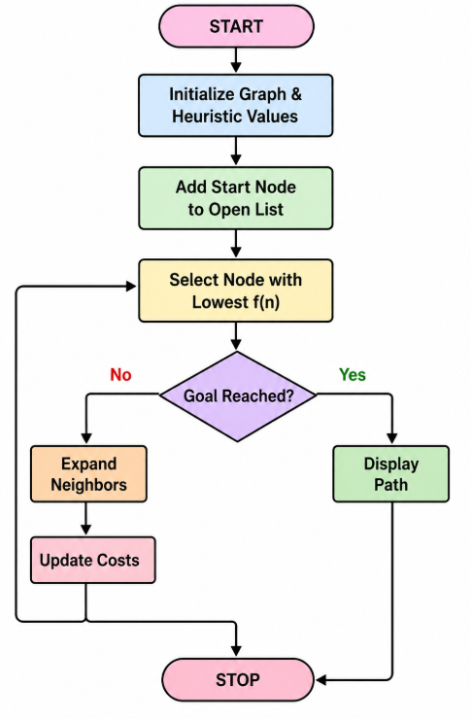
PROGRAM
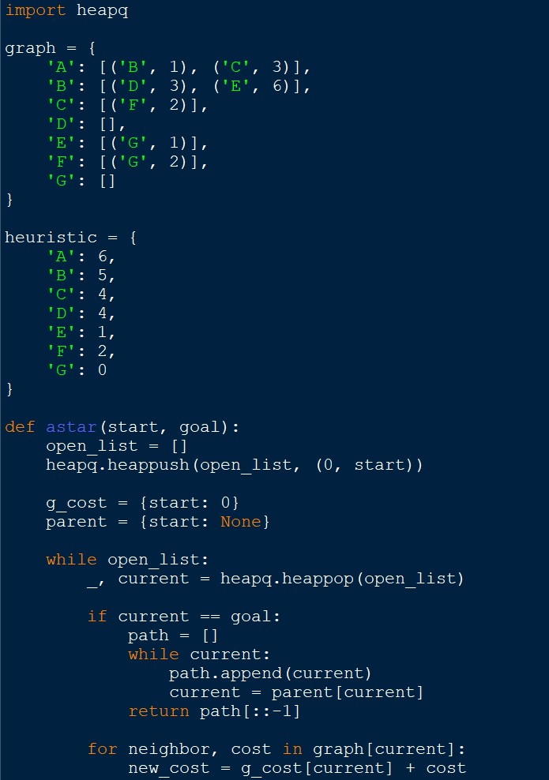

OUTPUT

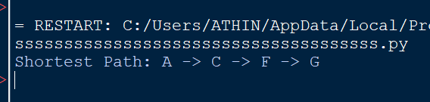

Result
The A* algorithm was successfully implemented and found the shortest path from the start node to the goal node using heuristic values.

